When submitting an EPAF, the EPAF will tell you if the student employee qualifies for federal work-study or not. Under the “Hours Allotment (Work-Study Only) and “Work-Study Earning Allotment” there will be numbers indicating the amount of FWS the student has for the semester. In the example below, the student qualifies for 117.65 hours (if the rate of pay is $12.75 for the student) and a total of $1,500 in FWS for the semester.
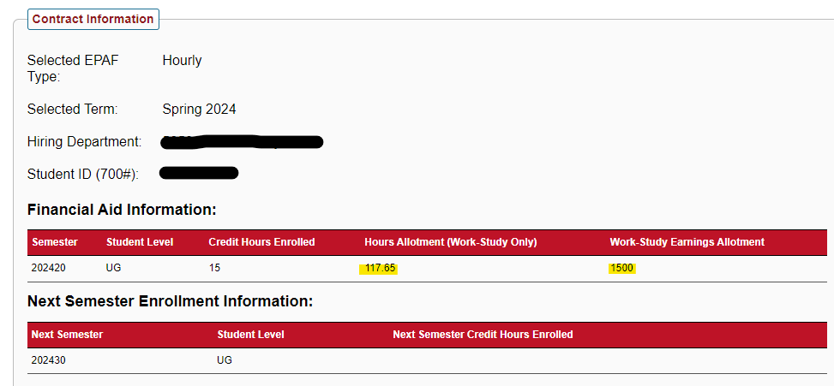
If the student has zeros in these fields, that indicates that the student does not qualify for FWS. If you believe your student should qualify for FWS, but there are zeros in that field, please contact the Financial Aid Office.
To determine the number of hours available to your student employee, it is important to remember that when using FWS, 75% of the hourly rate is paid from FWS funds and 25% of their hourly rate is paid by the department.

EXAMPLES
So, if you want to pay your student $12.75 an hour, 75% of $12.75 is $9.56. Therefore, for each hour your student is working, $9.56 will be charged to their FWS Earnings Allotment. Take the number of FWS allotment and divide it by $9.56 and that will give you the number of hours for the semester the student can work under FWS. For this example, $1500/$9.56 = 156.90. Therefore, your student can work roughly 156 hours under FWS. If you know your student will regularly work 20 hours a week, this will give your student about 7 to 8 weeks to work under FWS, tentatively, because 156/20 = 7.8.
If you are starting this student to begin working on August 16th, you know you have roughly 7-8 weeks of them working on FWS. 7-8 weeks after August 16th is roughly October 11th. The issue with switching from University Funded to FWS is that it must be done on a pay period ending and beginning. So, you could go ahead & submit a FWS EPAF for 08/16/20XX through 10/15/20XX then immediately turn around and submit an EPAF under University Funded for 10/16/20XX through 12/31/20XX. The system will allow two EPAF submissions under two position numbers back-to-back. This will eliminate the need for you to submit the SJ Change form and a new EPAF later in the semester.

If you want to pay your student $13.00 an hour, 75% of $12.75 is $9.75. Therefore, for each hour your student is working, $9.75 will be charged to their FWS Earnings Allotment. Take the number of FWS allotment and divide it by $9.56 and that will give you the number of hours for the semester the student can work under FWS. For this example, $1500/$9.75 = 153.84. Therefore, your student can work roughly 153 hours under FWS. If you know your student will regularly work 20 hours a week, this will give your student about 7 to 8 weeks to work under FWS, tentatively. 153/20 = 7.65
If you are starting this student to begin working on January 1st, you know you have roughly 7-8 weeks of them working on FWS. 7-8 weeks after January 1st is roughly February 26th. The issue with switching from University Funded to FWS is that it must be done on a pay period ending and beginning. So, you could go ahead & submit a FWS EPAF for 01/01/20XX through 02/28/20XX then immediately turn around and submit an EPAF under University Funded for 03/01/20XX through 05/3120XX. The system will allow two EPAF submissions under two position numbers back-to-back. This will eliminate the need for you to submit the SJ Change form and a new EPAF later in the semester.

If you want to pay your student $14.00 an hour, 75% of $12.75 is $10.50. Therefore, for each hour your student is working, $10.50 will be charged to their FWS Earnings Allotment. Take the number of FWS allotment and divide it by $10.50 and that will give you the number of hours for the semester the student can work under FWS. For this example, $1500/$10.50 = 142.86. Therefore, your student can work roughly 142 hours under FWS. If you know your student will regularly work 10 hours a week, this will give your student about 14 weeks to work under FWS, tentatively. 142/10 = 14.2
If you are starting this student to begin working on August 16th, you know you have roughly 14 weeks of them working on FWS. 14 weeks after August 16th is roughly November 22nd. The issue with switching from University Funded to FWS is that it must be done on a pay period ending and beginning. So, you could go ahead & submit a FWS EPAF for 08/16/20XX through 11/30/20XX then immediately turn around and submit an EPAF under University Funded for 12/01/20XX through 12/31/20XX. The system will allow two EPAF submissions under two position numbers back-to-back. This will eliminate the need for you to submit the SJ Change form and a new EPAF later in the semester.

