Enrollment Validation Procedures (EVP) for Faculty – Spring 2019 (201920)

Each faculty member is responsible for reporting students who do not attend the first day of class (or who do not report in Blackboard for online or hybrid classes) and have not made arrangements for their absence.

Please do not report students as absent who have made prior arrangements to miss the first day of class or students who have added the class after your first class meeting.

COURSES THAT EVP APPLIES TO

The Enrollment Validation Policy only applies to classes that meet the following conditions:

- Full semester and 1st half semester classes that begin Monday, January 14th – Sunday, January 20th
- 2nd half semester classes that begin Monday, March 11th – Sunday, March 17th
- Course must have a “part of term” of: FM, FT, FW, FR, FF, FS, FU, H1M, H1T, H1W, H1R, H1F, H1S, H1U, H2M, H2T, H2W, H2R, H2F, H2S, or H2U.
- Courses must be set up correctly on SSASECT (days/dates must be congruent, part of term and hours set up correctly, etc.). Errors on this screen can cause courses to be excluded.
- Students who add a course on or after the course start date will not be included on the Enrollment Validation list for faculty to validate. Their enrollment during the first week of classes validates their intent to participate in the course.

EXEMPT COURSES

The Enrollment Validation Policy does NOT apply to:

- Courses that do NOT begin during these dates: January 14-20 and March 11-17
- Off-schedule classes (not 16-week or 1st/2nd half semester classes; Parts of Term other than those listed above)
- Zero-credit classes
- Courses with a Schedule Type of: ABR-Study abroad, DOC-doctoral, DUA and DUL-dual credit, THR-THRIVE, IEP, and CEC and CEU-continuing education classes (if they are set up as such on SSASECT with this schedule type).

REPORTING/DROP SCHEDULE

If your class begins on: | And your class is: | You can begin reporting absences: | You must report absences in MyCentral before**: | Drops will occur after:
Monday, January 14th or Tuesday, January 15th | face-to-face | any time after the first class meeting | noon on Wednesday, January 16th | 10am on Thursday, January 17th
Monday, January 14th or Tuesday, January 15th | online or hybrid* | after noon on Tuesday, January 15th | noon on Wednesday, January 16th | 10am on Thursday, January 17th
Wednesday, January 16th - Sunday, January 20th | face-to-face | any time after the first class meeting | noon on Monday, January 21st | 10am on Tuesday, January 22nd
Monday, March 11th or Tuesday, March 12th | face-to-face | any time after the first class meeting | noon on Wednesday, March 13th | 10am on Thursday, March 14th
Monday, March 11th or Tuesday, March 12th | online or hybrid* | after noon on Tuesday, March 12th | noon on Wednesday, March 13th | 10am on Thursday, March 14th
Wednesday, March 13th - Sunday, March 17th | face-to-face | any time after the first class meeting | noon on Monday, March 18th | 10am on Tuesday, March 19th

*Make sure online and hybrid courses are available to students in Blackboard prior to January 14th (full semester classes and 1st half semester classes) or March 11th (2nd half semester classes) and that your EVP tool is available:

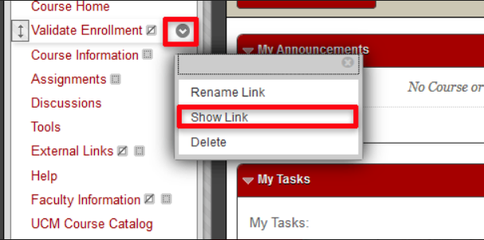

**Instructors may make changes to existing absence reports through this time (e.g. in the case of someone mistakenly reported absent, etc.). If you miss the deadline, there is nothing to do – you do not need to contact the Registrar’s Office. If this happens we recommend e-mailing the absent students and reminding them that they will need to drop the class in MyCentral before the 100% refund deadline, as they will not be dropped via the EVP process.

***ONLY STUDENTS WHO ARE REPORTED ABSENT ARE DROPPED. IF YOU DON’T REPORT ANYONE AS ABSENT – NO ONE IS DROPPED. So if you forget to do the Enrollment Validation process or if your students forget to validate their enrollment in online/hybrid courses – there is no risk of any student being dropped from any class unless the instructor has reported them as absent by the deadline above.

Students who add a course on or after the course start date will not be included on the Enrollment Validation list for faculty to validate. Their enrollment during the first week of classes validates their intent to participate in the course.

Questions about Blackboard or how to use/import/make available the Enrollment Validation tool in Blackboard may be directed to the Center for Teaching and Learning at ctl@ucmo.edu or 660-543-8528.

HANDY TIPS

- Absences are reported by faculty in MyCentral. Faculty may only report for classes which they are assigned to in SSASECT (INB Banner/Ellucian).

- Online and hybrid classes must be made available in Blackboard to your students prior to the first day of classes and must have the Enrollment Validation tool active.

- A student who adds the course on/after the first day should not show up on your EVP reporting list. These students should not be penalized for missing the first day of class.

- For online and hybrid courses, if you have students who are actively participating in the class but have not clicked the enrollment validation in Blackboard, do not report them as absent.

- After you save your enrollment validation in MyCentral, students reported as absent will immediately be sent a computer-generated e-mail message to let them know they been reported absent.

- The earlier that a student is reported absent, the more time they will have to check their e-mail and click the “save me” button prior to the drop of their class.

- If a student is reported absent and clicks on the “save me” button in their e-mail warning, they will not be dropped from the class.

- All Monday/Tuesday start classes will be dropped the morning of Thursday, January 17th (for full semester and 1st half semester classes) and the morning of Thursday, March 14th for 2nd half semester classes.

- All Wednesday-Sunday start classes will be dropped the morning of Tuesday, January 22nd (for full semester and 1st half semester classes) and the morning of Tuesday, March 19th for 2nd half semester classes.

- All classes are dropped with a full refund and no “W” will appear on the student’s transcript.

- The number of students dropped will be less than the number of students reported, as many students will have clicked on the “save me” button in their e-mail warning. This will prevent them from being dropped from the class.

ENROLLMENT VALIDATION PROCESS
FOR ONLINE AND HYBRID COURSES

The "Validate Enrollment" menu item and corresponding components have been added to your Blackboard course menu upon course creation. Make sure it remains in the menu and is available to students.

Online and hybrid classes must be made available in Blackboard to your students prior to the first day of classes for the semester or half semester (Monday, January 14th or Monday, March 11th).

HOW TO REPORT ABSENCES FOR ONLINE AND HYBRID CLASSES

- Students have until noon on Tuesday, January 15th (and noon on Tuesday, March 12th for 2nd half semester classes) to validate their enrollment in online and hybrid classes.

- If you have students who are actively participating in the class but have not clicked the enrollment validation in Blackboard, do not report them as absent.

- To report absences for online and hybrid classes, log into Blackboard after noon on Tuesday, January 15th through noon on Wednesday, January 16th for full semester and 1st half semester classes (and noon on Tuesday, March 12th through noon on Wednesday, March 13th for 2nd half semester classes)

- Access the section in Bb for which you will be verifying Enrollment Validation.

- Select the Validate Enrollment content area from your course menu.

- Click the drop down arrow to the right of the “Validate Enrollment …” item and select User Progress.

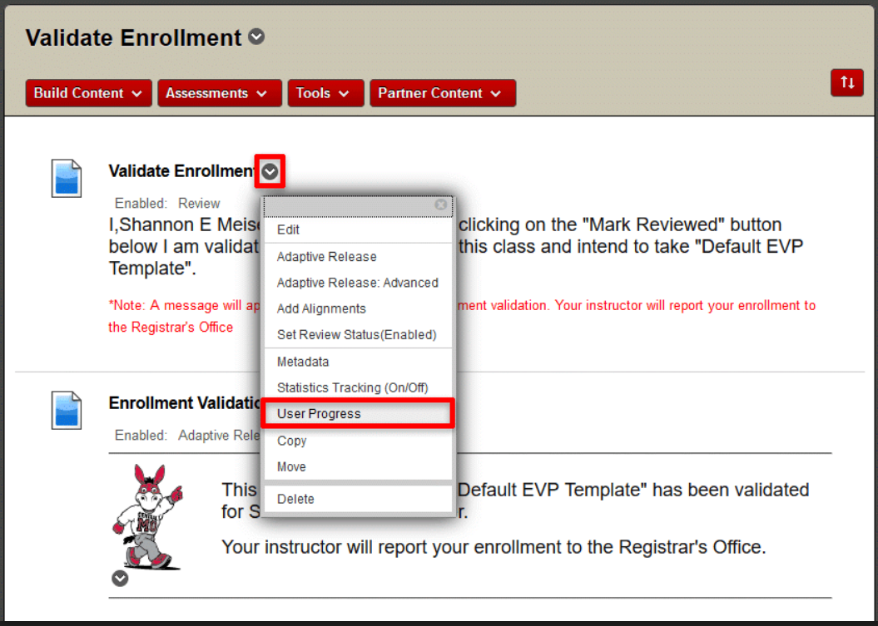

- You can sort the information on the User Progress screen using the column headings. Click the “Reviewed” column heading to sort by reviewed status.
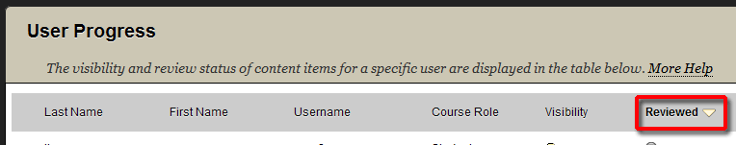

- The users who have validated enrollment will show a blue check mark icon in the Reviewed column. Users who have NOT validated enrollment will show a gray circle icon and will not have a date in the “Date Reviewed” column.

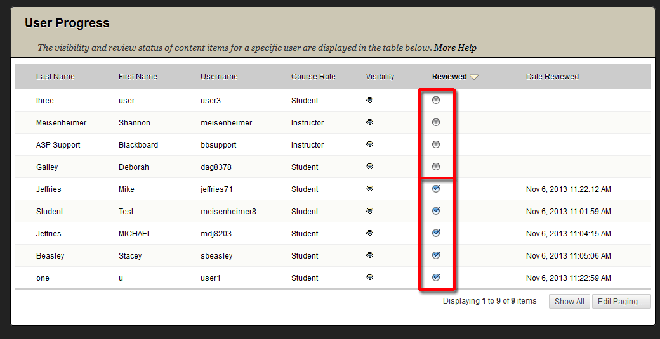

- Print this screen or make note of the students who did not validate enrollment (gray circle).
- Report absences in MyCentral before noon on Wednesday, January 16th for full semester and 1st half semester classes (and noon on Wednesday, March 13th for 2nd half semester classes). The earlier a student is reported, the more time they have to click the “save me” button in their warning e-mail before the drops occur.

- See the next set of instructions below for how to report absences in MyCentral.

HOW TO REPORT ABSENCES IN MYCENTRAL

- Log into MyCentral. (Can’t log in? Call the Technology Support Center at 660-543-4357.)

- In the Faculty Home Tab choose “EVP” (Enrollment Validation Policy) in the right-hand column.

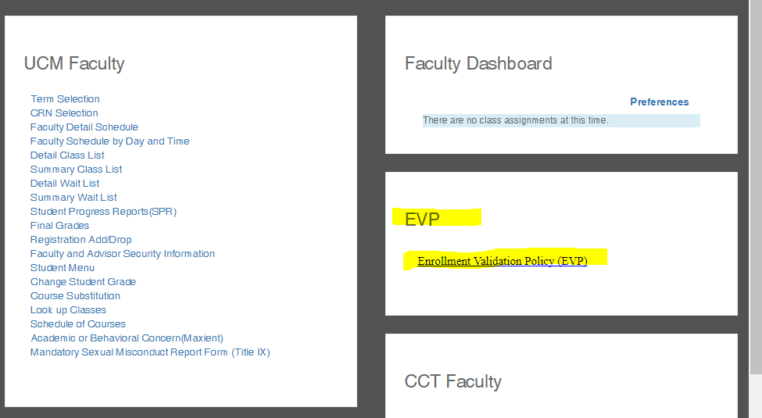

- Choose the CRN (course reference number) of the course you wish to report.
  - Access to report online and hybrid classes will be available between noon on Tuesday, January 15th through noon on Wednesday, January 16th for full semester and 1st half semester classes (and noon on Tuesday, March 12th through noon on Wednesday, March 13th for 2nd half semester classes).
  - Access to report student absences in face-to-face Monday/Tuesday start classes is available immediately following the first class and needs to be completed before noon on Wednesday, January 16th for full semester and 1st half semester classes (and noon on Wednesday, March 13th for 2nd half semester classes).
  - Access to report student absences in face-to-face Wednesday-Sunday start classes is available immediately following the first class and needs to be completed before noon on Monday, January 21st for full semester and 1st half semester classes (and noon on Monday, March18th for 2nd half semester classes).

- For each course, choose one of the following options:
  - If all students attended, check the box “Perfect Attendance”.
  - If the course did not meet during the first week mark the second option.
  - If you had absences, mark the individual students who were absent.

- Click the “Submit” button when finished.

- If you need to make changes to what you have reported, you may do so before noon on the reporting deadline for the course (see chart on page 2 of these instructions). Changes cannot be made after this time.

- Students who are accidentally reported and dropped from class may re-enroll in MyCentral if the add deadline has not passed and if the course still has seats available. If the add deadline has passed, students will need permission for a late enrollment from the course school chair and instructor. The schools may process the re-enrollment.

THEN WHAT HAPPENS?

- After you save your enrollment validation in MyCentral, students reported as absent will immediately be sent a computer-generated e-mail message to let them know they have been reported absent and will be dropped from the class if they do not act by the deadline. This message will include a “save me” button that the students can select to not be dropped from the class.

- If a student contacts the instructor directly to be “saved” (instead of using the “save me” button in the e-mail that they received), please follow steps described above in MyCentral and uncheck the button by their name and submit changes.
  - This can only be done if the reporting deadline has not passed.
  - If the reporting deadline has passed, and the student has already been dropped, they can add the class back in MyCentral if the add date has not passed and if there is still a seat available. If the add date has passed, they will need permission for a late enrollment from the course school chair and instructor. The schools may process the re-enrollment.
  - If the reporting deadline has passed, and the student has not yet been dropped, contact the Registrar’s Office at x4914.

- The EVP reporting screen will not be available to report absences for Monday/Tuesday start classes or to “save” a student after 12:00 noon on Wednesday, January 16th for full semester and 1st half semester classes (and noon on Wednesday, March 13th for 2nd half semester classes). The EVP reporting screen will not be available to report absences for Wednesday-Sunday start classes or to “save” a student after 12:00 noon on Monday, January 21st for full semester and 1st half semester classes (and noon on Monday, March 18th for 2nd half semester classes).

- Monday/Tuesday start classes will be dropped the morning of Thursday, January 17th (for full semester and 1st half semester classes) and the afternoon of Thursday, March 14th for 2nd half semester classes. Wednesday-Sunday start classes will be dropped the morning of Tuesday, January 22nd (for full semester and 1st half semester classes) and the afternoon of Tuesday, March 19th for 2nd half semester classes.

- Students who are dropped will receive an e-mail confirmation that they have been dropped. If they wish to re-enroll, they may do so in MyCentral if the add date has not passed for the course and if there is still a seat available. If the class is full or if the add date has passed, they will need permission for a late enrollment from the course school chair and instructor. The schools may process the re-enrollment.

FREQUENTLY ASKED QUESTIONS

- I teach an online class. I have a student who has done work for the course, but has not validated their enrollment in Blackboard. Do I report them as absent?
  - If you believe that a student intends to participate in your course – do not report them as absent! If you are unsure, e-mail the student for confirmation. Instruct them to drop the class in MyCentral if they do not plan to participate.

- I teach a face-to-face class. I have a student who missed the first day, but came on the second day. Do I report them as absent?
  - If you believe that a student intends to participate in your course – do not report them as absent! If you are unsure, ask or e-mail the student for confirmation. Instruct them to drop the class in MyCentral if they do not plan to participate.

- I have a student who was not on my roster on the first day of class, but is now on my roster. Do I report them as absent?
  - A student who adds the course on/after the first day should not show up on your EVP reporting list. These students should not be penalized for missing the first day of class. Do not report the student as absent.

- I’m in MyCentral and one of my classes isn’t in the list to choose.
  - Are you assigned as the course instructor in SSASECT (INB Ellucian/Banner)? You must be assigned to the course.

- I forgot to report my absences and the reporting deadline has passed. What can I do?
  - Late reports cannot be entered. If the student continues to not attend, report them via the Maxient Early Alert System in MyCentral and be sure to post the appropriate Student Progress Report during week six and final grade.

- I have a student who did attend the first week of classes, but has since stopped attending. What do I do?
  - E-mail the student(s) and instruct them to drop the course in MyCentral if they do not plan to attend. The last day to drop a full semester course is Friday, March 29th. The last day to drop a 1st half semester course is Friday, February 15th and the last day to drop a 2nd half semester course is Friday, April 19th.
  - If the student continues to not attend, report them via the Academic or Behavioral Concern (Maxient) form available in the UCM Faculty tab in MyCentral and be sure to post the appropriate Student Progress Report during week 6 and final grade. Any final grade of F must include the last attendance/participation date of the student to comply with federal financial aid guidelines.

STUDENT COMMUNICATIONS

- The entire student body is sent a minimum of two e-mails devoted to EVP directly from the Registrar’s Office.

  - The first occurs before the beginning of the semester and describes the policy.
  - The second occurs after all of the drops are completed, asking students to log into MyCentral to review their schedule.

- Students are also sent information regarding Enrollment Validation multiple times via personal e-mail, the UCM Weekly e-mail, Facebook, and Twitter.

- Students who are reported as absent receive two additional e-mails from the Registrar’s Office.

  - The first is a warning e-mail that is automatically generated when a faculty members reports them as absent in MyCentral.
  - The second occurs after the student has actually been dropped from the course (if they didn’t click on the “save me” button in the first e-mail warning).

