Spring 2019 (201920) EVP Instructions for Students

WHAT IS ENROLLMENT VALIDATION?
The purposes of the enrollment validation policy (EVP) are:
- to validate that students intend to participate in enrolled courses and to promote academic success by establishing a pattern of regular class attendance
- to improve access to courses by making seats available in full classes as students who do not plan to attend withdraw from classes
- to reduce educational costs by facilitating University compliance with federal financial aid regulations.

WHICH OF MY CLASSES ARE AFFECTED?
- The EVP takes place at the beginning of every semester/session (fall, spring, and summer). This includes half semester classes and all five summer sessions. It affects both undergraduate and graduate level students/classes.
- The EVP applies to all full-semester and first half-semester class beginning between Monday, January 14th – Sunday, January 20th, and any second half-semester courses that begin Monday, March 11th – Sunday, March 17th.
- The EVP does not apply to “off-schedule” classes (classes that begin outside of the dates above), dual credit, doctoral credit, THRIVE classes, study abroad, IEP, continuing education, and zero-credit classes.
- If you enroll in a class on or after the first day of that class, the instructor will not be able to report you as absent. It is assumed that if you add a class at this time that you intend to participate in it.
REPORTING/DROP SCHEDULE
If your class begins on: | And your class is: | You must validate enrollment by: | If you are reported absent, but wish to remain in the class, click the button in the e-mail you received before*: | Drops will occur after:
Monday, January 14th or Tuesday, January 15th | face-to-face | attending the first class meeting | 8am on Thursday, January 17th | 10am on Thursday, January 17th
Monday, January 14th or Tuesday, January 15th | online or hybrid | validating enrollment in Blackboard by noon on Tuesday, January 15th | 8am on Thursday, January 17th | 10am on Thursday, January 17th
Wednesday, January 16th - Sunday, January 20th | face-to-face | attending the first class meeting | 8am on Tuesday, January 22nd | 10am on Tuesday, January 22nd
Monday, March 11th or Tuesday, March 12th | face-to-face | attending the first class meeting | 8am on Thursday, March 14th | 10am on Thursday, March 14th
Monday, March 11th or Tuesday, March 12th | online or hybrid | validating enrollment in Blackboard by noon on Tuesday, March 12th | 8am on Thursday, March 14th | 10am on Thursday, March 14th
Wednesday, March 13th - Sunday, March 17th | face-to-face | attending the first class meeting | 8am on Tuesday, March 19th | 10am on Tuesday, March 19th
*If you are reported absent for a class, but do want to remain enrolled, click on the button included in the e-mail that you received. This will remove you from the absence list and you will not be dropped from the class.

WHAT DO I, AS A STUDENT, HAVE TO DO?

There is a different process for Enrollment Validation for classes that meet face-to-face and those that are online or hybrid.
FOR FACE-TO-FACE CLASSES
Attend each class on the first day the class is scheduled to meet. You can find your course start dates and meeting times in MyCentral. Go to the Student Services tab, choose Student Home, and in the UCM Registration block in the left-hand column click on Student Detail Schedule.

Make sure that the instructor has included you when they take attendance. If you arrive to class late, be sure to check in with the instructor before you leave.

If you are unable to attend on the first day, you must contact each class instructor prior to the first class day to indicate your intention to continue enrollment. You can find contact information for instructors in the Campus Directory online at https://www.ucmo.edu/campus-directory/index.php. It is recommended that you both call and e-mail your instructors.

FOR ONLINE AND HYBRID CLASSES
Log into Blackboard and go into each online and hybrid class. Follow the instructions below. You must do this by noon on Tuesday, January 15th for full semester and first-half semester classes (and by noon on Tuesday, March 12th for second-half semester classes – we’ll remind you via e-mail about this later!). Note: if you added the class on or after the first day of the course, you cannot be reported as absent by the professor – so if you add after this deadline, you are fine and it is assumed you will participate in the course.

- Access the section from your course list in Bb in which you will be validating enrollment.
- Click the Validate Enrollment link from the course menu.
- Read the displayed statement. If you agree and intend to take the course, click the Mark Reviewed button.
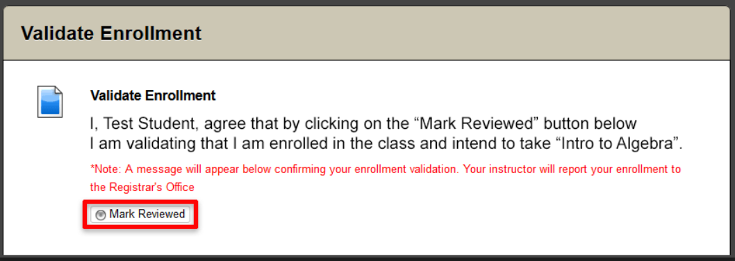
- Upon clicking the Mark Reviewed button a confirmation message will display that you have validated enrollment for this particular course.
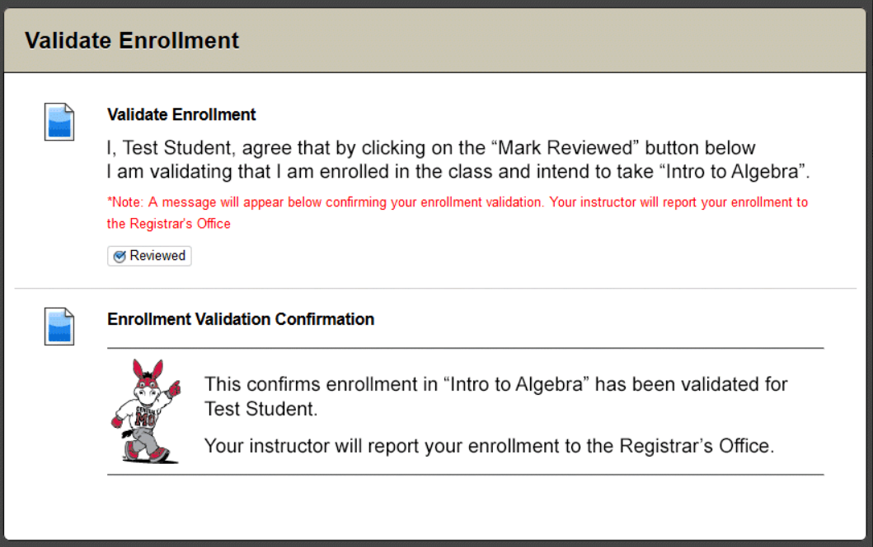
- Repeat the above steps for any other online or hybrid course(s). These steps are not necessary for face-to-face classes that happen to use Blackboard.
WHAT HAPPENS IF I AM REPORTED ABSENT?

If you are reported as absent (in either a face-to-face, online, or hybrid course) you will receive a computer-generated e-mail notifying you that you will be dropped for nonattendance. This will happen immediately after the instructor reports you as absent. This e-mail will include a “save me” button. Click on this button before 8am on the fourth day after the start of the class to be saved from being dropped.

Drops for Monday/Tuesday start classes will occur during the morning of Thursday, January 17th for full semester and 1st half semester classes (and Thursday, March 14th for 2nd half semester classes). Drops for Wednesday-Sunday start classes will occur during the morning of Tuesday, January 22nd for full semester and 1st half semester classes (and Tuesday, March 19th for 2nd half semester classes). If you are dropped from a class, you will receive a second e-mail after the drop has occurred.

If you wish to remain in a Monday/Tuesday start course, you will have until 8am on Thursday, January 17th for full semester and 1st half semester classes or 8am on Thursday, March 14th for 2nd half semester classes to click on the button included in the e-mail that you received. This will remove you from the absence list and you will not be dropped from the class.

If you wish to remain in a Wednesday-Sunday start course, you will have until 8am on Tuesday, January 22nd for full semester and 1st half semester classes or 8am on Tuesday, March 19th for 2nd half semester classes to click on the button included in the e-mail that you received. This will remove you from the absence list and you will not be dropped from the class.

WHAT HAPPENS IF I AM DROPPED FROM A CLASS?
If you are reported absent and do not click on the button to be “saved” included in the e-mail that you received, the Registrar’s Office will drop your class(es). All drops for Enrollment Validation are processed with a 100% refund. There will be no record of the class on your transcript and you will not be charged for the course.

If you are dropped from a class and are fine with that (you did not plan to attend the course), you do not need to do anything.

If you are dropped from a class and wish to get back into it, you may add the course back if it’s during the add period (through midnight on the 4th day of classes for full-semester classes) and there is a seat available. If it is after the add period, you will need to seek permission to re-enroll from the school chair and professor of the course. Find contact information for instructors in the Campus Directory online at https://www.ucmo.edu/campus-directory/index.php. It is recommended that you both call and e-mail your instructors. You can find enrollment deadlines at https://www.ucmo.edu/current-students/office-of-the-registrar-and-student-records/dates-and-deadlines/index.php.

The EVP is heavily dependent upon communication between students and faculty.
Therefore, it is critically important that students check their student email account
often during the week before classes begin and during the first several weeks of the semester.

DO NOT ASSUME THAT AN INSTRUCTOR HAS REPORTED AN ABSENCE. ENROLLMENT AND DIS-ENROLLMENT IS THE RESPONSIBILITY OF THE STUDENT. STUDENTS WHO FAIL TO DROP THE CLASS WILL BE HELD FINANCIALLY RESPONSIBLE FOR THE CLASS AND WILL RECEIVE A GRADE OF “F” IN THE CLASS.

