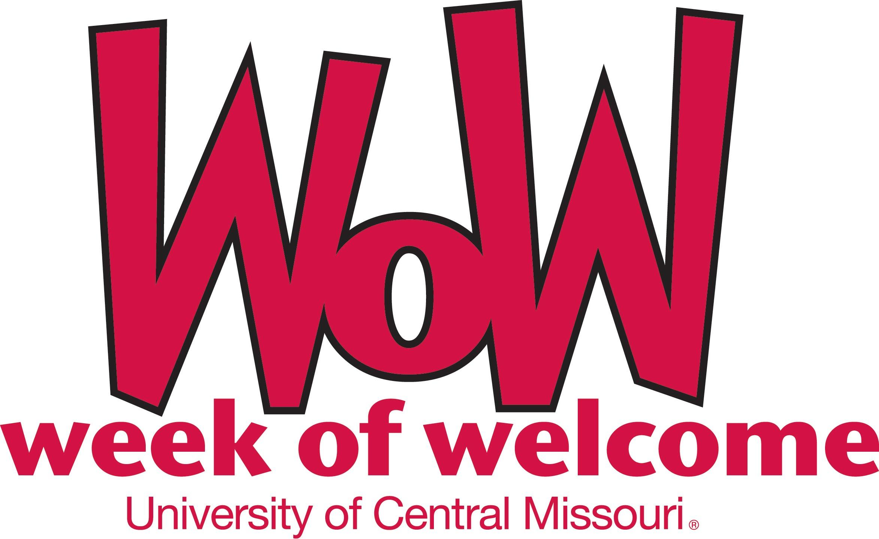

Sunday, August 12
10:00 am – 2:00 pm Residence Hall Open
10:00 am Donuts and rides to local churches sponsored by the Navigators Campus
Ministries, Alumni Chapel
12 - 2 pm Class Tours - bring your schedule and student ambassadors and mule team leaders will help you locate your classrooms, Elliott Union - Mall Entrance
7:00 pm Ice Cream on the Lawn, Central Baptist Student Union
8:00 -11:00 pm The Union Experience, Union (bowling, movie, archery, inflatables, ping pong, karaoke, and more
7:00 pm Ultimate Frisbee sponsored by the Navigators Campus Ministries, East
Field

Monday, August 13 – CLASSES BEGIN
6:00 pm Fraternity & Sorority Informational Session, Union 240
6:00 pm Ice Cream at the Newman Center
7:00 & 9 pm Hypnotist, Jim Wand, Hendricks Hall
Sponsored by USHA & SFC

Tuesday, August 14

6:00 pm Fraternity and Sorority Informational Session, Union 240
6:00 pm Free Chipotle Burritos (First 300 Students) at Central Baptist Student Union
6:00 pm Navigator’s Campus Ministries Welcome BBQ, 1030 Anderson St.

Wednesday, August 15
8:00 am Sorority Recruitment Registration Deadline
3:00 – 5:00 pm Involvement Fair, SRWC Gym
5:30 pm Fraternity House Tours, Union 236
8:00 pm Comedian Jenny Zigrino, Hendricks Hall

Thursday, August 16
9:00 am - 3:00 pm “Give Red” Blood Drive , Union 238 & 240
5:30 pm Fraternity Recruitment, each chapter facility
6:00 pm Back to School Bash sponsored by Central BSU, Baptist Student Union
8:00 pm Nav Night sponsored by the Navigators Campus Ministries, Alumni Chapel
8:00 pm UCM Bingo, Union 240

Friday, August 17
11:00 am – 2:00 pm Wear Red! Be Proud!, Union Mall
4:30, 7 & 9:30 pm Union Cinema Movie: Union Cinema
8:00 pm – midnight MAD on the Block, East Field

Saturday, August 18
1:00 pm Open Gym sponsored by Navigators Campus Ministries, SRWC
4, 6:30 & 9:30 pm Union Cinema Movie: Union Cinema

