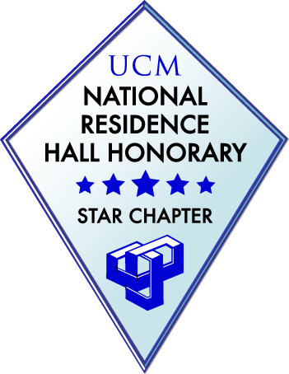

Dear Student Leader,

Thank you for having interest in the 12th annual National Residence Hall Honorary (NRHH) & United Student Housing Association (USHA) scholarship. The goal of this scholarship is to recognize and award two residents for their hard work in the residence halls and dedication to residence life. We are looking for two individuals who have dedicated their Fall 2018/Spring 2019 year to making a difference in their residence hall and who are planning to contribute to their residence halls during the Fall 2019/Spring 2020 year. We are awarding two separate scholarships each in the amount of $250.

Criteria:

1. Must have lived in the residence for at least 1 year

2. Involvement in residence hall leadership in an unpaid position

3. Minimum GPA of 2.5

4. Two letters of recommendation (one must be from a CA, RHD, or Housing

Organization Advisor)

5. Essay (no more than 2 pages) explaining your involvement in residence hall leadership

this year (Fall 2019-Spring 2020) and describing your plans to stay involved in the residence halls during the coming academic year.

6. Live in University Housing during the 2019-2020 academic year.

If you choose to apply, please return the application, essay, and letters of recommendation to

NRHH/USHA Scholarship   
  c/o Jay Hicks  
  University Housing Office  
  Ellis Complex L23

Due: April 1, by 5:00 pm

Materials can also be emailed to jhicks@ucmo.edu

Winners of the scholarship will be announced during the Star Reception on April 28, 2019. You will receive the scholarship early Fall 2019, upon confirmation of your check-in to the residence hall. Again thank you for your interest in the NRHH & USHA scholarship and your involvement in Hall Council, USHA, and NRHH.

Sincerely,

Stephen Plants Alicia Resch

*NRHH President* *USHA President*



NRHH/USHA Scholarship Application Form

- - - - - - - - - - - - - - - - - - - - - - - - - - - - - - - - - - - - - - - - - - - - - - - - - - - - - - - - - - - - - - - - - - -

NAME: ______________________________________________________________

RESIDENCE HALL: _____________________________________________________

I am currently a (pick one): Freshman Sophomore Junior Senior

MAJOR: ___________________________ GPA: ______

UCM 700#_________________________

CURRENT POSITION IN HALL COUNCIL, USHA, OR NRHH: _________________________________________

HOW MANY SEMESTERS HAVE YOU LIVED ON CAMPUS? (Including Spring 2019 ) _________

HOW MANY SEMESTERS DO YOU PLAN ON CONTINUING ON LIVING ON CAMPUS? (From Fall 2019 until _________)