Submit a Work Order for Your Room

Maintenance requests, commonly known as work orders, are requests submitted when there is a maintenance issue that requires attention in a residential room, apartment or common living space. Examples of maintenance requests include:
- Leaking, clogged or slow draining sinks or toilets
- Burned out light fixtures or non-functioning electrical outlets
- Air conditioner or heating unit issues
- Door lock issues
- Wall repair
- Damaged university-owned furniture
- Window issues

How do I submit a work order?
There are a variety of ways to submit work orders to allow for optimal convenience for residents.
- Work orders can be submitted 24 hours a day by calling Facilities, Planning and Operations directly at 660-543-4331. You can also check the status of your work request by calling this number.

- Another way to submit work orders it to contact the front desk of the building you are in or the CA. The hall staff member will then contact the on-call staff member to respond to the situation. Contacting the front desk or hall staff is the best approach to submit an emergency request after regular business hours.

- You can also submit online via MyCentral on the left side Student Services page.

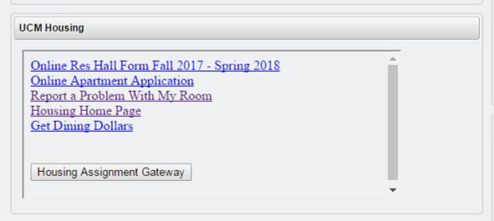
You do not have to be in your room to have the work done. When you submit a work request, you authorize facilities staff to enter your room or apartment to complete the work task. Maintenance staff will leave a notice alerting you of entry to perform the work requested.

What information will I need to provide?
When submitting a work order, you will need to provide your:
- Name
- Phone number
- Building and room number
- Detailed description and location of the issue being reported

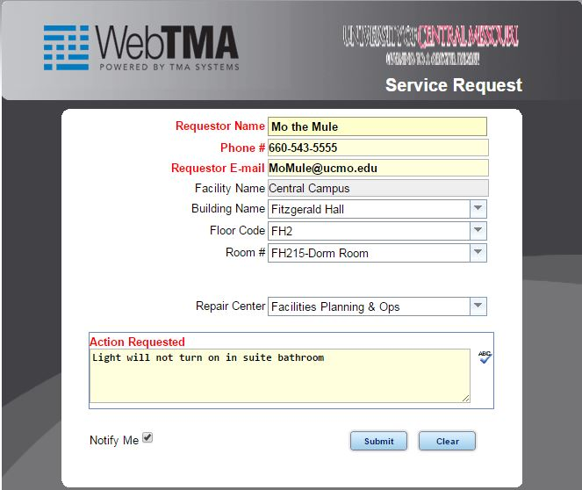

How long does it take a work request to be processed?
Work orders are completed in a timely manner; however, work orders are prioritized when necessary. For example, a sink that is overflowing will take priority over items such as a broken closet door. Issues that directly affect health and safety will take priority.
Additional Contacts
If you experience issues with any of the following, please contact the appropriate office:
- Charter Cable – please contact the main housing office at 660-543-4515
- Washers/Dryers and Vending Machines– please contact the front desk of the building the washers and dryers are located in
- Internet – please contact the Office of Information Technology at 660-543-4357
- Pest Control – please contact the main housing office at 660-543-4515

