1. When you have received notification from Financial Aid that your student worker is nearing their FWS allotment, there are two thing you will need to do.

NOTE: THIS SWITCH MUST BE DONE AT THE BEGINNING/END OF A PAY PERIOD

2. The first step of the process to submit a Student Job Change form to terminate the current Federal Work Study Position.

As you are going through the form, it is going to ask you “Are you needing to terminate the student's job earlier than the original termination date submitted on the Student Job Assignment form?” You will need to answer that question as “Yes”.

The very next question is “Date change is effective?” This date needs to be the last day of the pay period in which you are wanting to end the Federal Work Study Funding. For example, you are wanting to switch your student over to University Funded effective the 10/01/20XX pay period, you will need to enter this field 09/30/2023. If you are switching them to University Funded effective the 10/16/20XX, you will need to enter this field 10/15/2023.

There will be an “Additional Comments” question. Here you should enter “Exhausted FWS funding. Switching over to full University Funded.”

Submit this form. This is all that needs to be done to terminate the FWS position.

3. Now, you need to begin a University Funded position. You will need to do this through the EPAF form.

When selecting the position number, you must now select the University Funded position number available to you, rather than the Federal Work Study Number.

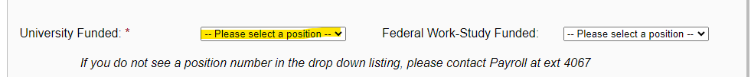

“Job Start Date” should indicate the beginning of the pay period in which the University Funded should go into effect. Again, this must be the beginning of the pay period, for example 10/01/20XX or 10/16/20XX.

If you have any other questions on how to complete the EPAF form, please refer to these directions here.

NOTE: WHEN SUBMITTING THE EPAF IF YOU GET THE ERROR, “PLEASE START NEW JOB DATE AFTER LAST JOB END DATE FOR THE SAME POSITION” AS THE PICTURE BELOW SHOWS…
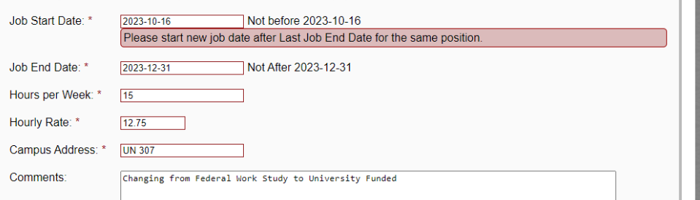

…this indicates that you initial EPAF at the beginning of the semester was submitted under the University Funded position number & HR manually overrode that to be Federal Work Study Funded instead. The system will not allow two submissions under the same organization number under the same position number for the same semester.

If this happens, you will need to go back and submit another Student Job Change form.

This time, go through the process of completing the SJ Change form, but in the comments section this time, please indicate something to the effect of “Please begin students job under position number ________ for the dates of XX/XX/XX - XX/XX/XX at $(hourly rate) under FOAPAL: ________________________.

HR will manually begin the new UF position.

